[Organisation] · PHASE C
Application Reference Model
Eighteen purposes, the approved application for each, and what to do when the answer is not one you like
Field | Detail
Version | 0.1 — Draft
Date | October 2027
Owner | Application Domain Architect
Approver | Architecture Board
Source | Applications and dispositions from metamodel O23. Standard status derived from disposition and lifecycle. Purposes and guidance authored here and submitted under CR-041.
Classification | Internal

1. How to use this
This is the approved list. A solution architect reads it at design; the Architecture Board reads it at G2. It answers what to use before a project picks for itself.

Status | What it means | Derived from | Count
Current | The standard. Use it unless there is a reason not to, and record the reason. | Extend or Sustain, and Current lifecycle | 16 applications
Emerging | The intended standard, not yet in production. Design to it, do not build on it yet. | Build disposition, Emerging lifecycle | 5 applications
Contained | In use and not the standard. Keep what is there, add nothing new. | Consolidate or Replace disposition | 4 applications
Retiring | Being switched off. Nothing new, and existing use needs an exit date. | Retire disposition | 1 application
No standard | No application is in production for this purpose. An Emerging one may be named as the target. | Derived: the purpose has no Current application | 3 purposes

1.1 Five rules
Rule | What it means | Why
Use the Current standard by default | If a purpose has a Current application, use it. | A deviation is an architecture decision, not a project preference. It goes to the Architecture Board with a stated reason.
Never build new on Contained or Retiring | Contained means keep what exists. Retiring means plan the exit. | New capability on LIFE/400 or BrokerNet is the single most common way the replacement date moves out by a year.
Design to Emerging, build on Current | An emerging standard tells you the shape of the target. | CustomerHub is the intended party master and does not exist. Design as if it will; integrate to what runs today.
Integration goes through the managed layer | No new point-to-point interface, and no direct database read under any circumstance. | Forty-four of fifty interfaces are unmanaged and four read another application's tables. Neither is a precedent.
Where there is no standard, say so | Three purposes have no designated application. | The honest answer is that the estate has no answer. Inventing one in a solution design is how a sixth customer master gets built.

Three purposes have no application in production
Holding a party record, configuring a product, and integrating two systems. Each has an Emerging application named as the target and none is live. The honest answer at a design review is that the estate has no answer, and inventing one is how a fifth party master gets built.

2. The reference model
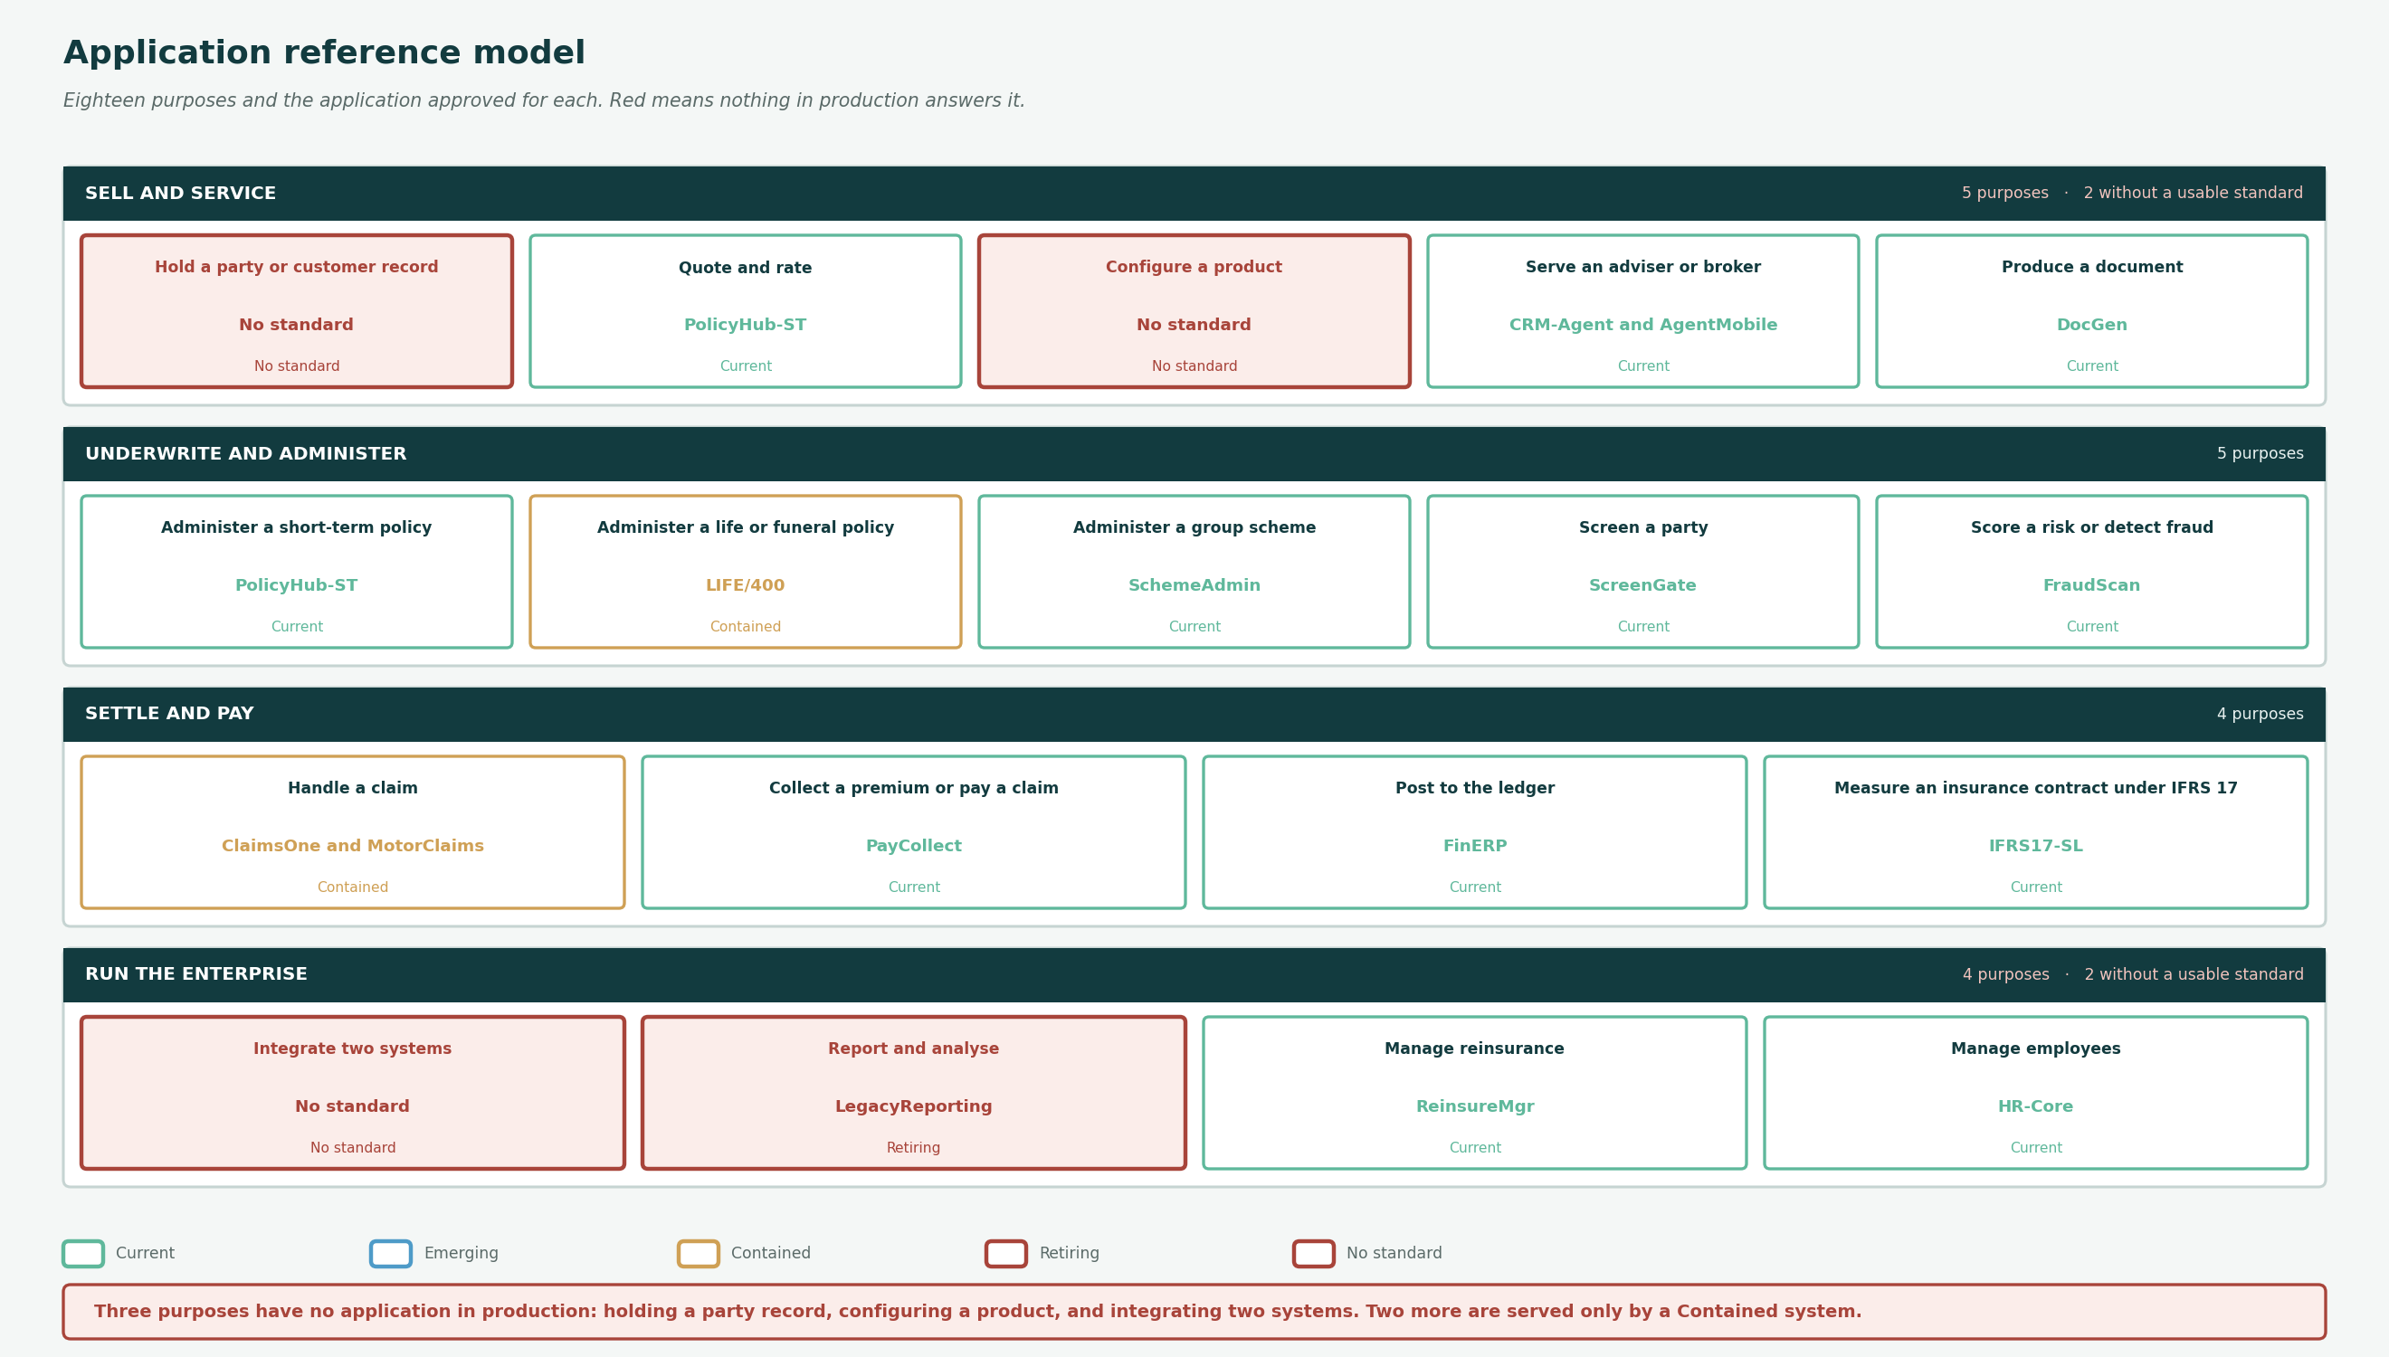
Eighteen purposes grouped into four domains. Red means nothing in production answers the purpose.

3. Purpose by purpose

Hold a party or customer record
Create and maintain the identity of a person or organisation.
Standard today | No standard (No standard)
At target | CustomerHub
When to use it | Today the answer depends on the channel: LIFE/400, PolicyHub-ST, SchemeAdmin or BancaBridge.
When not to | Do not create a new party store. Four exist and 2.6 million records sit across them against 1.9 million policies.

Administer a short-term policy
Issue, endorse and maintain a non-life contract.
Standard today | PolicyHub-ST (Current)
At target | PolicyHub-ST
When to use it | Every new short-term product. It carries fourteen interfaces, so plan the integration early.
When not to | Not for life or funeral business, which sits on LIFE/400.

Administer a life or funeral policy
Issue and maintain a life contract.
Standard today | LIFE/400 (Contained)
At target | Undecided
When to use it | Only for what is already there. It is Legacy, Tier 1, R68.4m a year and marked Replace.
When not to | No new product. The Statement of Architecture Work excludes the replacement decision, so there is no successor to point at.

Administer a group scheme
Maintain a scheme and its membership.
Standard today | SchemeAdmin (Current)
At target | SchemeAdmin
When to use it | Employee benefits and group risk.
When not to | Not for individual contracts. Scheme membership is not a customer record, and treating it as one is why party counts do not reconcile.

Quote and rate
Produce a binding quotation.
Standard today | PolicyHub-ST (Current)
At target | PolicyHub-ST with ProductStudio
When to use it | Short-term rating. WebQuote for the direct digital channel.
When not to | Rating factors for nine of eighteen products are in code, not configuration. Changing one is a release, not a change.

Configure a product
Define and change a product without a code deployment.
Standard today | No standard (No standard)
At target | ProductStudio
When to use it | ProductStudio is the intended standard and is not live.
When not to | Until it is, product change is a platform release. Do not design as though configuration exists.

Handle a claim
Register, assess and settle.
Standard today | ClaimsOne and MotorClaims (Contained)
At target | One of the two, undecided
When to use it | Use the one the product already sits on: ClaimsOne for life and funeral, MotorClaims for motor and property.
When not to | Both carry Consolidate and neither disposition names the target. Do not assume which survives.

Collect a premium or pay a claim
Move money in or out.
Standard today | PayCollect (Current)
At target | PayCollect
When to use it | All collection mandates, debit orders and disbursements.
When not to | Disbursement waits for the overnight batch. If a use case needs same-day payment, raise it as a requirement rather than working around it.

Post to the ledger
Record a financial transaction.
Standard today | FinERP (Current)
At target | FinERP
When to use it | Everything financial. It carries eleven interfaces and is the second most connected system in the estate.
When not to | Not for IFRS 17 measurement, which is IFRS17-SL.

Measure an insurance contract under IFRS 17
Group, measure and report contract movements.
Standard today | IFRS17-SL (Current)
At target | IFRS17-SL
When to use it | All IFRS 17 measurement and the sub-ledger.
When not to | It reads FinERP tables directly today. That interface is one of four direct database reads and is on the list to remove.

Screen a party
Sanctions, PEP and due diligence screening.
Standard today | ScreenGate (Current)
At target | ScreenGate
When to use it | Onboarding, claims payment and periodic rescreening. It is the best performing service in the catalogue.
When not to | Beneficiary screening before payment is not implemented. The entity has no logical component, so there is nothing to screen against.

Score a risk or detect fraud
Apply a model to a case.
Standard today | FraudScan (Current)
At target | FraudScan with ModelOps
When to use it | Claims fraud scoring at notification.
When not to | No model register exists. A model in production today has no recorded owner, version or monitoring status.

Serve an adviser or broker
Give an intermediary a working surface.
Standard today | CRM-Agent and AgentMobile (Current)
At target | CRM-Agent, AgentMobile and a replacement for BrokerNet
When to use it | Tied agents and the contact centre use CRM-Agent; the field uses AgentMobile.
When not to | BrokerNet serves 3,400 brokerages, is Legacy and marked Replace. Nothing new on it.

Integrate two systems
Move data between applications.
Standard today | No standard (No standard)
At target | API Gateway
When to use it | The API Gateway is the intended standard and is not live.
When not to | Until it is, a new interface is a point-to-point one. Record it, do not hide it, and never use a direct database read.

Produce a document
Generate and store customer correspondence.
Standard today | DocGen (Current)
At target | DocGen
When to use it | All outbound correspondence and policy documents.
When not to | Retention is recorded per document type and enforced by nothing. Do not rely on it to dispose.

Report and analyse
Answer a question from data across the estate.
Standard today | LegacyReporting (Retiring)
At target | Enterprise Data Platform
When to use it | LegacyReporting is being switched off and still supports eight capabilities.
When not to | Nothing new on it. The Enterprise Data Platform is the target and is recorded against three entities while nine data sets draw on nineteen.

Manage reinsurance
Record treaties and cessions.
Standard today | ReinsureMgr (Current)
At target | ReinsureMgr
When to use it | Treaty and cession recording.
When not to | Recovery tracking sits in a spreadsheet outside it. The function it serves contains no modelled process, so the guidance here is thinner than for anything else.

Manage employees
Hold employee and organisational data.
Standard today | HR-Core (Current)
At target | HR-Core
When to use it | All employee records.
When not to | Not a source of actor or role data for the architecture. The role catalogue is held in the repository and eight roles have no actor performing them.

4. The approved list
Twenty-six applications by standard status, derived from disposition and lifecycle.

Ref | Application | Status | What it is | Criticality | Lifecycle | Disposition | Run cost Rm
APP-26 | AgentMobile | Current | Offline-capable adviser application for field sales. | Tier 2 | Current | Extend | 6.4
APP-18 | BancaBridge | Current | Integration and servicing layer for the bancassurance partner. | Tier 1 | Current | Extend | 7.1
APP-08 | ContactCentre CTI | Current | Telephony, routing and agent desktop integration. | Tier 1 | Current | Sustain | 9.4
APP-05 | CRM-Agent | Current | Customer relationship management for the tied agency force. | Tier 2 | Current | Extend | 14.3
APP-13 | DocGen | Current | Document composition, print and dispatch. | Tier 2 | Current | Sustain | 7.3
APP-11 | FinERP | Current | General ledger, procurement, accounts payable and receivable. | Tier 1 | Current | Sustain | 26.4
APP-15 | FraudScan | Current | Rules and model-based fraud scoring for claims and applications. | Tier 2 | Current | Extend | 6.8
APP-19 | HR-Core | Current | Human resources, payroll and adviser remuneration. | Tier 2 | Current | Sustain | 9.8
APP-12 | IFRS17-SL | Current | IFRS 17 measurement sub-ledger and disclosure engine. | Tier 1 | Current | Sustain | 15.8
APP-10 | InvestAdmin | Current | Linked investment product administration. | Tier 2 | Current | Sustain | 5.2
APP-14 | PayCollect | Current | Debit order, payroll, card and cash collection engine. | Tier 1 | Current | Extend | 13.6
APP-02 | PolicyHub-ST | Current | Short-term policy administration, personal lines only. | Tier 1 | Current | Extend | 41.2
APP-16 | ReinsureMgr | Current | Treaty administration, cession and recovery. | Tier 2 | Current | Sustain | 4.9
APP-09 | SchemeAdmin | Current | Group employee benefits scheme and member administration. | Tier 1 | Current | Sustain | 12.1
APP-17 | ScreenGate | Current | Sanctions, PEP and due diligence screening. | Tier 1 | Current | Sustain | 5.6
APP-07 | WebQuote | Current | Public quote-and-buy journey for motor and household. | Tier 1 | Current | Extend | 8.9
APP-20 | API Gateway | Emerging | Managed integration layer, gateway and interface catalogue. | Tier 1 | Emerging | Build | 0
APP-21 | CustomerHub | Emerging | Master data management and identity resolution for party and customer. | Tier 1 | Emerging | Build | 0
APP-22 | Enterprise Data Platform | Emerging | Governed analytical platform with lineage and self-service. | Tier 1 | Emerging | Build | 0
APP-24 | ModelOps | Emerging | Model register, monitoring and explainability tooling. | Tier 2 | Emerging | Build | 0
APP-23 | ProductStudio | Emerging | Business-maintained product configuration workbench. | Tier 1 | Emerging | Build | 0
APP-06 | BrokerNet | Contained | Broker portal for quotation, binding and claim status. | Tier 1 | Legacy | Replace | 11.7
APP-03 | ClaimsOne | Contained | Life and funeral claims administration. | Tier 1 | Legacy | Consolidate | 22.6
APP-01 | LIFE/400 | Contained | Life and funeral policy administration on the mainframe. | Tier 1 | Legacy | Replace | 68.4
APP-04 | MotorClaims | Contained | Short-term claims administration with panel integration. | Tier 1 | Current | Consolidate | 19.8
APP-25 | LegacyReporting | Retiring | Departmental spreadsheet and Access-based reporting estate. | Tier 3 | Legacy | Retire | 3.2

5. Findings
Three of eighteen purposes have no standard application
Holding a party record, configuring a product and integrating two systems.
All three have an Emerging application named and none in production. A solution architect asking what to use today gets no answer, and the honest response is to say so rather than let a project choose. Inventing an answer is how a fifth party master gets built.
Two purposes are served only by Contained applications
Administering a life policy, and handling a claim.
Contained means keep what is there and add nothing. For life administration there is no successor because the replacement decision is out of scope; for claims both candidates carry Consolidate and neither names the target. These are the two places a project will be told no without being told what instead.
Sixteen applications are Current and they cover most of what anyone needs
Policy administration, collection, ledger, IFRS 17, screening, documents, scheme administration and the adviser surfaces.
The reference model is not mostly gaps. It has a working core and three holes, and naming which is which is what makes it usable at a design review rather than an aspiration.
The integration rule is the one that will be broken
No new point-to-point interface and no direct database read, against an estate where 44 of 50 are unmanaged and four read tables directly.
The standard is right and there is no managed layer to route through until the API Gateway is live. Stating the rule without the platform means every project needs an exception, which makes the exception the norm.
The model is authored and the repository holds none of it
Purposes, guidance and standard designations are all new. The metamodel records what exists, not what anyone should choose.
That is the gap this artifact fills and the reason it should go into the repository under CR-041 rather than live as a document. A reference model held in a slide deck is a reference model nobody checks against.

Referenced artifacts
- Application Portfolio Catalogue · Information Systems Landscape · Function to Application Mapping
- Application Communication · Software Distribution · Data Architecture Blueprint
- Metamodel O23 Application Component. The reference model itself is not yet held in the repository; raised as CR-041.

